Region of Waterloo

Community Services

Housing Services

To: Chair Geoff Lorentz and Members of the Community Services Committee
Date: August 14, 2018 File Code: S13-40
Subject: Housing and Homelessness Update Summer 2018

Recommendation:
For information

Summary:
This report provides an update on housing and homelessness, as informed by the 2017/18 Housing Stability Data Summary, the April 2018 Point-in-Time Count, as well as shelter data from April to July 2018 sourced from the new, web-based Homeless Individuals and Families Information System or HIFIS 4. The last update was provided to Community Services Committee in December 2017 (see CSD-HOU-17-28). The current report includes new data and additional context.

The 2017/18 Housing Stability Data Summary shows that Waterloo Region is facing a number of significant challenges specific to poverty, access to affordable rental housing, and access to services/supports that help people experiencing homelessness to find and keep a home. The Emergency Shelter System is also experiencing pressures related to capacity for single men.

Local Housing Stability System redesign efforts within the broader community and human services integration within the Region’s Community Services Department are focused on improving quality of life by delivering more seamless, client-centred service (see CSD-HOU-18-16 for a progress update related to the local 10 Year Housing and Homelessness Plan). In addition to these efforts, more resources are required to help people living in poverty with their housing issues. More specifically, people need greater access to prevention and diversion services, affordable rental housing (e.g., rent assistance), housing help to find and secure a home, and intensive support to stay housed from a wide range of specialized systems (e.g., physical health, addictions, mental health, and other disability-related or specialized supports).

Report:

1.0 Background to the Data Sources
Three main data sources were used to inform this report, including: 1) the 2017/18 Housing Stability Data Summary (Data Summary; attached as Appendix A); 2) shelter data sourced from the new, web-based Homeless Individuals and Families Information System or HIFIS 4; and 3) the 2018 Point-in-Time Count (PiT Count). Each is described more fully below.
- Data Summary: Report on indicators related to housing and homelessness in five areas: 1) emergency shelter; 2) income; 3) rental housing; 4) Community Housing; and 5) housing support. Data is presented for the past three years and change from the previous year is calculated. Results were compiled from several sources.
- HIFIS 4 Shelter Data: In April 2018, the Emergency Shelter Program transitioned to a new, web-based database (HIFIS 4) hosted on the Region’s server. This has provided the Region and Shelter Providers with real-time access to information about shelter use. Data in this report is sourced up to July 28.
- PiT Count: Snapshot of homelessness for Waterloo Region though an anonymous, voluntary survey (see CSD-HOU-17-09 and CSD-HOU-17-15). On April 23, 2018, over 90 staff and volunteers surveyed people staying in shelters, staying in transitional housing, or sleeping unsheltered in the region. In addition, three weeks prior to this date, staff from the Wilmot Family Resource Centre surveyed individuals and families accessing the Wilmot Food Bank every Thursday in an effort to include a census of homelessness in a rural community. The survey included questions about gender identity, age, Indigenous status, and veteran status; results complement more real-time HIFIS data.
This report is organized into three sections of updates and related key messages:
1) Homelessness; 2) Income; and 3) Rental and Community Housing. Refer to Appendix B for an outline of all twelve key messages and Appendix C for an additional summary that provides more detail about the ten key messages specific to homelessness.

2.0 Homelessness Update
Homelessness trends are described in three parts below: sheltered (see 2.1), unsheltered (see 2.2), and chronic (see 2.3). For more detail and data sources, see Appendix C.

2.1 Sheltered Homelessness
Over the last five years, the Emergency Shelter System has experienced some significant changes and pressures, including a new funding model in 2013 to align with the new provincial Community Homelessness Prevention Initiative (CHPI), release of a new Emergency Shelter Framework in 2017 (CSD-HOU-17-07) and, most recently, occupancy pressures for single men that led to opening a temporary, overnight drop-in in the winter months (see CSD-HOU-18-01 and CSD-HOU-18-21 for more information).

Key messages:
- The Emergency Shelter System has capacity to serve 245 people on-site every night of the year. Some providers serve only youth, while others serve a mix of youth, singles and/or families. Most of the spaces are in the larger adult-serving shelters (80 percent) and more are located in Kitchener (60 percent) compared to other area municipalities within Waterloo Region. When shelters reach their on-site capacity, they first access other available beds in the system, and then access motel overflow spaces. The three larger adult-serving shelters each have an additional 10 motel spaces for overflow. There are other options being explored for when demand exceeds this. See Appendix C for more information about emergency shelter capacity.
- Sheltered homelessness increased dramatically over the fall of 2017 and then dropped below historic averages by the summer of 2018. Between April 2015 and July 2018, average nightly occupancy was 232. Over 2017/18, this rose to an average of 331 between October and January 2018 before dropping to 211 in June and then increasing to 226 in July with increasing demand from families. The period of high occupancy was stressful and difficult for shelter participants, shelter workers, and Regional staff. Service Providers and the Region worked together to meet the need for shelter during this time in a variety of ways: offering a flexible, temporary drop-in between February 1 and April 30; starting a new, centralized approach to prevention and diversion services beginning May 1; and deploying more help for shelter participants to find and secure housing.
- Fewer people were served in shelter last year than ever before but it is taking single households (mostly males) longer to find housing. Single households experiencing homelessness with longer stays need access to more housing help and rent assistance to improve housing outcomes.
- People who stay in shelters represent a mix of different groups living in poverty and most are Waterloo Region residents. The largest group of people experiencing homelessness continues to be adult men.

2.2. Unsheltered Homelessness
It is possible to know the number of people experiencing homelessness who connect with the Housing Stability System through local programs or participant surveys. However, this under-represents the actual number of people living without a permanent home because there is no way to know the total number of people experiencing homelessness who cannot or choose not to connect with the Housing Stability System. This includes some people who are currently living in unsheltered situations that do not access shelter. For example, available HIFIS data does not adequately represent the needs of people that are unable to access shelter (e.g., due to service restrictions related to behaviours from a previous stay) or choose not to access shelter (e.g., some people find being in close proximity to other people too difficult to manage or can’t meet the expectations specific to substance use onsite).

2018 PiT Count and real-time PATHS data can approximate the number of people living in unsheltered spaces who choose to connect with the Housing Stability System. The 2018 PiT Count identified that 38 people planned to sleep in an unsheltered space that night. This is similar to the number of people identified as sleeping in unsheltered spaces while they wait for housing support on the PATHS list (39 as of June 2018). More real-time data will be available on the extent of unsheltered homelessness when Street Outreach providers funded by the Region transition to HIFIS 4 over 2018/19.

Discussions with community partners about the needs of people experiencing homelessness who are not able or interested in accessing shelter have highlighted gaps in service related to harm reduction/low barrier housing options and specialized, flexible addiction and mental health supports (see CSD-HOU-18-21 for more information). Addressing this gap will require a collaborative approach between many different community systems.

Key messages:
- It is only possible to know the number of people experiencing homelessness who are seeking access to services or willing to be counted. While local enumeration efforts will improve, it is not possible to know the number of people experiencing homelessness who cannot or choose not to connect with the Housing Stability System.
- At any point in time, there are about 40 people living in unsheltered spaces seeking access to services from the Housing Stability System. There are more people who are unconnected who may benefit from health and housing services. Street Outreach workers are available to make connections with this group but it will take a collaborative effort between different community partners engaged in street-based, flexible and specialized services/supports to address the unmet health and housing needs of people who are living in unsheltered spaces.

See a summary of homelessness enumeration in Appendix C for more information.

2.3 Chronic Homelessness
Ending chronic homelessness is a priority for Waterloo Region. The Province has set a goal to end chronic homelessness across Ontario by 2025 and the Federal Government has set a goal to reduce chronic homelessness in half over the next decade.

To reach this goal locally, a new, centralized approach to accessing housing support was launched in 2018 called the Prioritized Access to Housing Support (PATHS) process (see CSD-HOU-17-27 and CSD-HOU-18-09). The PATHS process coordinates access to housing support programs funded by the Region of Waterloo, including vacancies in Portable Home-Based Support and Supportive Housing. In 2018, a redesigned Portable Home-Based Support Program was also launched (see CSD-HOU-17-26 and CSD-HOU-18-10).

Both Portable Home-Based Support and Supportive Housing programs are only eligible for people experiencing homelessness with greater depth of need. There is a long waiting list for these support programs. More resources are required to realize the full benefit of the PATHS process redesign, including more Service Navigators to help people get offer-ready and Housing Liaisons that help people throughout the housing process (e.g., finding vacancies, viewings, lease-ups, and move-ins). In addition, more staff are needed to meet the demand for Portable Home-Based Support (offered through new “Home Teams”). Housing Support Coordinators help people who have been offered support through the PATHS process to recover from homelessness and connect with additional, specialized services for longer term housing stability. Finally, there is a need for more Supportive Housing, particularly programs that have specialized physical health, addictions, mental health and other disability-related services dedicated to supporting tenants in the building.

At the same time, there is significant progress being made through the PATHS process. For example, the number of people who were housed from the PATHS list increased by 87 percent in the last year (from 115 to 215). In addition, the portion of people on PATHS with the deepest level of need has decreased by 36 percent (from 53 percent to 17 percent) – this is a direct result of prioritizing people with the deepest needs first. Results from the STEP Home pilot in Cambridge were very positive – 62 people with the highest level of need were housed through the pilot (exceeding initial housing move-in target of 50 people by 24 percent). Some individuals had been living without housing for many years. The pilot had a 95 percent housing retention rate. Only eleven participants lost their housing during the pilot; eight of whom were successfully re-housed. The success of the pilot informed the PATHS and Portable Home-Based Support Program redesigns described above.

Despite these positive housing outcomes, there are currently 288 people waiting for housing support (a 19 percent increase since 2016/17). People continue to be added and removed from the PATHS list on a daily basis and data about inflow and outflow from the PATHS list is shared monthly with community partners.

Key messages:
- Coordinated strategies to help youth and families with housing issues are working. Integrating two new prevention and diversion initiatives, funded by the Ontario Poverty Reduction Strategy, with existing programs funded by the Region will be a priority. Addressing the needs of youth with complex housing issues also remains a priority.
- More focus on homelessness prevention, shelter diversion and rapid re-housing will improve housing outcomes. Building on the success of local pilots and new policy directions that prioritize best practices is a priority.
- People with greater depth of need (acuity) often need more intensive services to find and keep a home. Building on the success of local pilots and new policy directions that prioritize best practices is a priority.
- Housing First is working and needs more resources. Building on the success of local pilots and new policy directions that prioritize best practices is a priority.

4.0 Income Update
While the minimum hourly wage increased by 23 percent to $14 over the last year, it is still not enough to afford even a bachelor apartment at average market rent in the region (at $802, this would require an hourly wage of $15.42).

In addition, low social assistance rates continue to exacerbate housing barriers. The monthly shelter allowance for a bachelor apartment (at an average cost of $802 as at December 2017) remains impossible to afford using the shelter portion of the OW allowance ($384) or ODSP allowance ($489).

Key message:
- Housing remains unaffordable for many households living in poverty, most notably singles. Single households earning minimum wage or accessing social assistance are unable to afford average market rent. As a result, they are at an increased risk of housing instability.

5.0 Rental and Community Housing Update
The net number of private market rental units available in Waterloo Region (excluding purpose-built student housing) increased by six percent over the previous year (an additional 2,190 units). However, the vacancy rate declined slightly to a new low of 1.9 percent which remains 1.1 percent below what housing researchers indicate is a “healthy rate” of three percent. The cost of private market rentals continues to increase year over year (four to five percent for bachelors, one-bedroom and two-bedroom units).

The number of completed Community Housing rental units increased by 47 (or 0.5 percent to a new capacity of 10,457). The number of households on the Community Housing waiting list as of December 2017 showed a 40 percent increase over the previous year. While the number of households on the waiting list does fluctuate from year to year, the number has hovered around 3,000 for the last decade until very recently. Some of this increase is due to more newcomer families applying after their sponsoring year is over, and more efforts at getting people experiencing homelessness on the list, plus some more streamlined processing of applications. Average wait times for Community Housing are now three years for seniors and at least seven years for bachelor and one-bedroom units.

Key message:
- The vacancy rate remains very low and the waiting list for Community Housing is growing. In a tight rental market, households must expand their housing search to include the widest possible range of units (e.g., across the whole region). People facing barriers (e.g., poor credit or references) may need some additional help to secure a new unit from workers with special skills in the area of finding and securing housing.

6.0 Overall Homelessness and Housing Update Summary
The 2017/18 Housing Stability Data Summary shows that Waterloo Region is facing a number of significant challenges specific to poverty, access to affordable rental housing, and access to services/supports that help people experiencing homelessness to find, secure and keep a home. For example, there is a growing demand for Community Housing (particularly from single households), fewer vacancies in both Community Housing and the overall rental market, and significant affordability pressures on single households accessing social assistance or earning minimum wage.
The Emergency Shelter System is also experiencing pressures related to capacity for single men. On average, 242 people stayed in shelter every night between April 2017 and March 2018, an increase of 12 percent in daily bed occupancy from the previous fiscal period. While there were actually fewer unique individuals accessing shelter over this time, single adults (primarily men) stayed longer than ever before. This contributed to a surge in chronic homelessness in shelter (a 40 percent increase). Despite these pressures, to date, no one from Waterloo Region has been turned away because the Emergency Shelter System does not have a “cap”. This was possible over the last year using motel bed spaces for overflow and using the Temporary Winter Overnight Drop-in option, which temporarily increased capacity to serve until April 30 (see CSD-HOU-18-21 for more information). Of note, in May 2018, average daily occupancy dropped to 231 people per night and it was 226 per night in July 2018.

In addition, Housing Stability Service Providers are managing a growing demand for more intensive housing support from people with a high level of need. Without these additional supports in place, people experiencing homelessness often find it very difficult to regain stability in their lives. More specifically, the Housing Stability System is struggling to adequately serve people experiencing homelessness with high level of need while they wait to be offered more appropriate housing options and access to the physical health, addictions, mental health, and other disability-related services that can help them to stay housed. While people wait for these specialized services, Street Outreach, Emergency Shelters, and Housing Resource Centre staff offer service within the scope of their mandates; however, their limited level of service is often simply not enough. People experiencing homelessness with a high level of need often need access to permanent housing and ongoing, intensive supports to recover from homelessness and address the issues that are making it hard for them to maintain stability in their lives.

There are notable bright spots specific to progress over the last year, however, including a six percent increase in rental market units, an increased supply of Community Housing (47 units), the 87 percent increase in housing move-ins through the PATHS process and overall reduction in youth and family homelessness. Over 2017/18, average shelter occupancy was 60 percent for youth shelters and both the number of families in shelter and length of stay were reduced by 14 percent and 21 percent, respectively.

Local Housing Stability System redesign efforts within the broader community and human services integration within the Region’s Community Services Department are focused on improving quality of life by delivering more seamless, client-centred service (see CSD-HOU-18-16 for a progress update related to the local 10 Year Housing and Homelessness Plan). In addition to these efforts, more resources are required to help people living in poverty with their housing issues. More specifically, people need greater access to prevention and diversion services, affordable rental housing (e.g., rent assistance), housing help to find and secure a home, and intensive support to stay housed from a wide range of specialized systems (e.g., physical health, addictions, mental health, and other disability-related or specialized supports).

7.0 Next Steps
The 2017/18 Housing Stability Data Summary complements the Region’s 10 Year Housing and Homelessness Progress Report to the community (see CSD-HOU-18-16). As such, it will be forwarded to the Ministry of Housing. The document will also be shared widely with community partners by posting it to the Region’s website, posting it to the Homeless Hub national clearinghouse (www.Homeless Hub.ca), distributing it through the Homelessness and Housing Umbrella Group (HHUG) list serve and offering hard copies to community agencies for their use and further distribution.

In addition, this report describes 2018 PiT Count results, which are a deliverable to both the Ministry of Housing (as outlined in the Housing Services Act) and Federal Government (as outlined in the Service Agreement for funding the PiT Count event).

Finally, information outlined in this report will be featured in a number of new communication tools planned for release in the fall of 2018, including a series of Fact Sheets, FAQ documents, brochures and flyers about the following:
- The Housing Stability System
- Homelessness in Waterloo Region
- Coordinated Access to Housing Support and the PATHS Team
- Waterloo Region 20,000 Homes Campaign Progress Report 2018
- Coordinated Access to Community Housing
- Housing Resource Centres and the Rent Fund
- The Emergency Shelter Program
- The Street Outreach Program
- The Ontario Renovates Program
- The Affordable Home Ownership Program
- The Transitional Housing Program
- Portable Home-Based Support and the Home Teams
- The Supportive Housing Program

Quality of Life Indicators:
Addressing issues of housing and homelessness aligns with Economic Well-Being (e.g., increased access to affordable housing); Social Inclusion and Equity (e.g., housing support positively impacts participants’ sense of belonging and community participation); Physical and Emotional Well-Being (e.g., housing support positively impacts participants’ daily functioning and how they feel about their life) and Relationships (e.g., through access to housing stability workers that provide support).

Corporate Strategic Plan:
Working to strengthen the housing stability system and build the community’s capacity to address issues of housing instability and homelessness is consistent with the Region of Waterloo 2015-2018 Corporate Strategic Plan, Focus Area 4: Healthy, Safe and Inclusive Communities; and specifically, Strategic Objective 4.3.1 to “Implement the Homelessness to Housing Stability Strategy” and Strategic Objective 4.3 Increase the supply and range of affordable and supportive housing options.

Financial Implications:
Nil

Other Department Consultations/Concurrence:
Nil

Attachments
Appendix A: 2017/18 Housing Stability Data Summary
Appendix B: Housing and Homelessness Update – Key Messages (Summer 2018)
Appendix C: Homelessness Highlights for Waterloo Region (Summer 2018)

Prepared By: Angela Pye, Manager, Housing Services
Deb Schlichter, Director, Housing Services

Approved By: Douglas Bartholomew-Saunders, Commissioner, Community Services

Appendix A
2017/18 Housing Stability Data Summary
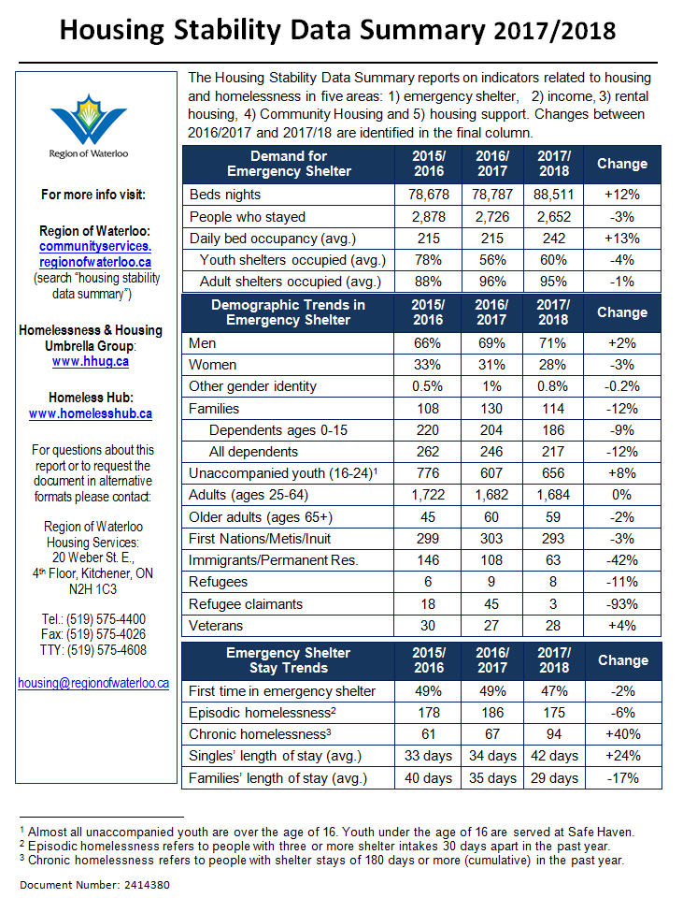

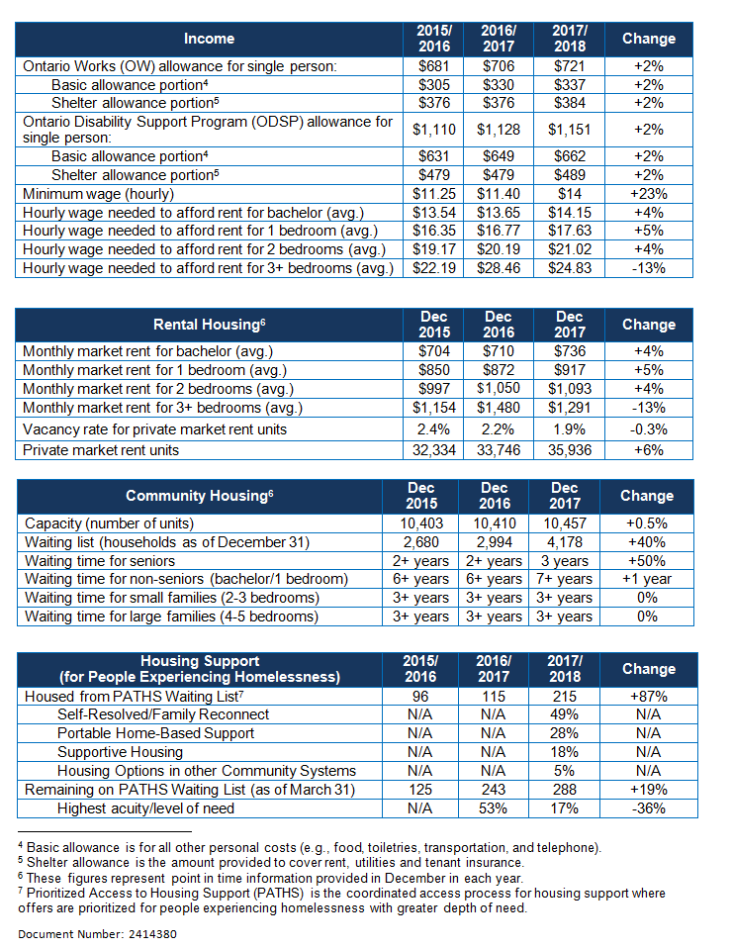

Appendix B
Housing and Homelessness Update – Key Messages (Summer 2018)

Responding to Occupancy Pressures in Shelter (“managing homelessness”)

- The Emergency Shelter System has capacity to serve 245 people on-site every night of the year.
- Sheltered homelessness increased dramatically over the fall of 2017 and then dropped below historic averages by the summer of 2018.
- Fewer people were served in shelter last year than ever before but it is taking single households (mostly males) longer to find housing.
  - Longer stays created occupancy pressures last year.
  - Average length of stay increased only for singles.
- People who stay in shelters represent a mix of different groups living in poverty and most are Waterloo Region residents.
  - Gender and age trends are fairly stable over time – more males and few seniors.
  - People who identify as First Nation, Metis or Inuit represent about 10 percent of shelter participants.
  - Veterans represent about one percent of shelter participants.
  - Fewer immigrants/permanent residents, refugees, and refugee claimants accessed shelter last year.
  - Almost all shelter participants are from Waterloo Region.

Connecting with the Street-Involved Population (“being ready to serve”)
- It is only possible to know the number of people experiencing homelessness who are seeking access to services or willing to be counted.
- At any point in time, there are about 40 people living in unsheltered spaces seeking access to services from the Housing Stability System.

Coordinating Access to Resources Based on Need (not “one size fits all” approach to ending homelessness)
- Coordinated strategies to help youth and families with housing issues are working.
  - Overall, housing stability for families is improving over time.
  - While more youth experienced homelessness last year, trends are still positive compared to 2015/16.
- More focus on homelessness prevention, shelter diversion and rapid re-housing will improve housing outcomes.
  - Nearly half of the shelter population is new to shelter – their stays could have been prevented.
  - More than half of the shelter population has low to moderate depth of need (acuity) – they can benefit from self-directed or rapid re-housing services.
- People with greater depth of need (acuity) often need more intensive services to find and keep a home.
  - A small number of participants return to shelter often – they may benefit from rapid re-housing services.
  - A small but growing number of shelter participants experience chronic homelessness – they likely need more intensive support.
  - Chronic homelessness accounts for nearly half of all shelter use in a year.
- Housing First is working and needs more resources.
  - Progress is being made with housing people through the PATHS process.
  - People who have experienced chronic homelessness with deep levels of need can stay housed.
  - More resources are needed to accelerate progress with ending chronic homelessness.

Low Rental Vacancies and Long Waiting Lists for Community Housing (“managing housing affordability pressures”)

- Housing remains unaffordable for many households living in poverty, most notably singles.
- The vacancy rate remains very low and the waiting list for Community Housing is growing.

Appendix C
Homelessness Highlights for Waterloo Region (Summer 2018)

Homelessness Highlights are organized into three themes based on 2017/18 data:
- Responding to occupancy pressures in shelter (“managing homelessness”)
- Connecting with the street-involved population (“being ready to serve”)
- Coordinating access to resources based on need (not a “one size fits all” approach to ending homelessness)
Responding to Occupancy Pressures in Shelter (“managing homelessness”)
Shelter data includes seven, year-round Region-funded providers (see Region’s website and Pocket Card). Unless otherwise cited, results are sourced from HIFIS. Where applicable, April 23, 2018 Point in Time (PiT) Count results are also cited.

- The Emergency Shelter System has capacity to serve 245 people on-site every night of the year. Some providers serve only youth, while others serve a mix of youth, singles and/or families. Most of the spaces are in the larger adult-serving shelters (80 percent) and more are located in Kitchener (60 percent) compared to other area municipalities within Waterloo Region. When shelters reach their on-site capacity, they access other available beds within the system and then overflow to motel spaces. Other options are being explored for when demand exceeds this.
Emergency Shelter Provider Capacity in Waterloo Region (2018).
Service Provider | Population | Capacity
Argus Residence for Young Men & Young Women, Cambridge | Youth 16-24 | 21 spaces
Cambridge Shelter, Cambridge | Males & Females 16+; Families | 78 spaces +  10 motel overflow
Charles Street Men’s Shelter, Kitchener | Males 16+ | 51 spaces +  10 motel overflow
oneROOF, Kitchener | Youth 16-25 | 17 spaces
Safe Haven, Kitchener | Youth 12-17 | 10 spaces
The Working Centre Bunkies, Kitchener | Males & Females 16+ | 2 spaces
YWCA Emergency Shelter, Kitchener | Females 16+;  Families  (incl. father-led) | 66 spaces +  10 motel overflow
7 Service Providers |  | 245 spaces +  30 overflow

- Sheltered homelessness increased dramatically over the fall of 2017 and then dropped below historic averages by the summer of 2018. Between April 2015 and July 2018, average nightly occupancy was 232. Over 2017/18, this rose to an average of 331 between October and January 2018 before dropping to 211 in June and then increasing to 226 in July with increasing demand from families. The period of high occupancy was stressful and difficult for shelter participants, shelter workers, and Regional staff. Service Providers and the Region worked together to meet the need for shelter during this time in a variety of ways: offering a flexible, temporary drop-in between February 1 and April 30; starting a new, centralized approach to prevention and diversion services beginning May 1; and deploying more help for shelter participants to find and secure housing.

- Fewer people were served in shelter last year than ever before but it is taking single households (mostly males) longer to find housing. Single households experiencing homelessness with longer stays need access to more housing help and rent assistance to improve housing outcomes.
- Longer stays created occupancy pressures last year. The total number of bed nights (88,511 over the year) and daily bed occupancy (242 people stayed per night on average) increased by 12 percent over the last year. However, the overall number accessing shelter (2,652) decreased by three percent (eight percent decrease since 2015/16 and lowest on record). Fewer households with more bed nights in a year mean longer lengths of stay on average.
- Average length of stay increased only for singles. Since last year, average length of stay for singles increased by eight days (nine since 2015/16). For families, it decreased by six days (11 since 2015/16).

- People who stay in shelters represent a mix of different groups living in poverty and most are Waterloo Region residents.
- Gender and age trends are fairly stable over time – more males and few seniors. Males represented 71 percent, an increase of two percent since last year. Seniors represented two percent in 2017/18 (same as last year).
- People who identify as First Nation, Metis or Inuit represent about 10 percent of shelter participants. Eleven percent identified as First Nations, Metis or Inuit in 2017/18 (293 people, down from 303 in 2016/17).
- Veterans represent about one percent of shelter participants. Veterans represent a small percentage of the shelter population – just one percent in 2017/18 (28 people, up from 27 in 2016/17).
- Fewer immigrants/permanent residents, refugees, and refugee claimants accessed shelter last year. Compared to the previous year, there were 42 percent fewer immigrants/permanent residents (63 compared to 108), 11 percent fewer refugees (8 compared to 9), and 93 percent fewer refugee claimants (3 compared to 45) in shelter over 2017/18.
- Almost all shelter participants are from Waterloo Region. An Emergency Shelter Participant survey showed 84 percent of participants identified Waterloo Region as home (April 2018). Most said their last address was in Kitchener (50 percent), followed by Cambridge (25 percent) and then Waterloo (nine percent).
Occupancy Trends from April 2015 to July 2018.

People Served in Shelter from 2006 to 2017/2018.

Connecting with the Street-Involved Population (“being ready to serve”)
- It is only possible to know the number of people experiencing homelessness who are seeking access to services or willing to be counted. While local enumeration efforts will improve, it is not possible to know the number of people experiencing homelessness who cannot or choose not to connect with the Housing Stability System.
- At any point in time, there are about 40 people living in unsheltered spaces seeking access to services from the Housing Stability System. There are more people who are unconnected who may benefit from health and housing services. Street Outreach workers are available to make connections with this group but it will take a collaborative effort between different community partners engaged in street-based, flexible and specialized services/supports to address the unmet health and housing needs of people who are living in unsheltered spaces.

Homelessness Enumeration in Waterloo Region (2018).
Type of Homelessness | 2017/18 Count
Sheltered Homelessness | 242 (average nightly shelter use)  (note historic average is 232)
Unsheltered Homelessness – Connected | 40 people  (based on 2018 PiT Count & PATHS)
Unsheltered Homelessness – Unconnected | Unknown
Total | 282 Connected People

Coordinating Access to Resources Based on Need (not “one size fits all” approach to ending homelessness)

- Coordinated strategies to help youth and families with housing issues are working. Integrating two new prevention and diversion initiatives, funded by the Ontario Poverty Reduction Strategy, with existing programs funded by the Region will be a priority. Addressing the needs of youth with complex housing issues also remains a priority.
- Overall, housing stability for families is improving over time. The numbers of families accessing shelter decreased by 14 percent over the last year (114 in 2017/18 compared to 130 in 2016/17) and they are staying for shorter periods of time on average (reduced by six days over the last year and 11 days since 2015/16). Region-funded family Service Providers have been working together intentionally for a number of years to offer seamless service to families through Families to Homes (F2H). Through this initiative, families are helped to find and keep a home by accessing a fully coordinated system of care. Services funded by the Region through F2H include prevention and diversion, rapid re-housing, affordable housing and, when needed, more intensive housing support. Results show this approach is working.
- While more youth experienced homelessness last year, trends are still positive compared to 2015/16. While the number of youth accessing shelter increased by eight percent, it was still 14 percent lower than 2015/16 and youth shelters had an average daily occupancy of 60 percent over 2017/18. Moving forward with implementing youth service pathways through the new Youth to Homes (Y2H) initiative will be a focus for 2018/19.
- More focus on homelessness prevention, shelter diversion and rapid re-housing will improve housing outcomes. Building on the success of local pilots and new policy directions that prioritize best practices is a priority.
- Nearly half of the shelter population is new to shelter – their stays could have been prevented. Nearly half of shelter participants accessed shelter for the first time in 2017/18 (47 percent, slightly less than previous years). Research and local experience has shown that many people don’t need shelter to resolve their housing issue. Instead, they may benefit more from housing help to work through their options and assist with referrals to other community services.
- More than half of the shelter population has low to moderate depth of need (acuity) – they may benefit from self-directed or rapid re-housing services. HIFIS data from the day of the PiT Count showed that 57 percent of shelter participants had a low to moderate level of support need. People with lower levels of need are more likely to be able to resolve their homelessness on their own. Rapid re-housing services can help them get connected to the community-based services that will help them to increase their housing stability as quickly as possible.
- People with greater depth of need (acuity) often need more intensive services to find and keep a home. Building on the success of local pilots and new policy directions that prioritize best practices is a priority.
- A small number of participants return to shelter often – they may benefit from rapid re-housing services. Seven percent of shelter participants experienced episodic homelessness (defined as three or more shelter stays in a 12-month period, with each shelter stay period separated by 30 or more days).
- A small but growing number of shelter participants experience chronic homelessness – they likely need more intensive support. Four percent of shelter participants accessed shelter for more than 180 days in the year (meeting the threshold of chronic homelessness), a 40 percent increase over the last year (94 in 2017/18 compared to 67 in 2016/17). Shelter participants experiencing chronic homelessness with a higher depth of need are prioritized for more intensive support to find and keep a home through the Prioritized Access to Housing Support (PATHS) process.
- Chronic homelessness accounts for nearly half of all shelter use in a year. Twenty percent of the households in shelter on the day of the PiT Count were experiencing chronic homelessness (51 of 258 households). Over the previous 12 months, their bed nights represented 46 percent of all bed nights for that year.
- Housing First is working and needs more resources. Building on the success of local pilots and new policy directions that prioritize best practices is a priority.
- Progress is being made with housing people through the PATHS process. More people experiencing homelessness with the deepest level of need are being housed through PATHS than ever before. Because people with the deepest level of need have been housed, the PATHS list now has fewer people from that group (36 percent less than last year). In Cambridge, housing targets for the STEP Home pilot were exceeded by 24 percent (the goal was 50 people and 62 were housed).
- People who have experienced chronic homelessness with deep levels of need can stay housed. Through the Cambridge STEP Home pilot, 95 percent of participants were able to retain their housing. This proves that, with access to affordable housing and appropriate levels of support, people with long histories of homelessness can and do regain housing stability.
- More resources are needed to accelerate progress with ending chronic homelessness. To reach the goal of ending chronic homelessness, more resources are needed. More staff resources are needed to help people on PATHS to get offer-ready and connect with landlords, more rent assistance is needed to help make housing more affordable, and more staff resources are needed to help people to stay housed after they move in to housing. Other unmet needs include funds to cover the cost of home set-ups and damages to units.

HIFIS 4 data between April 1 and July 28 is included in this report where applicable.
Where possible, homelessness data was sourced from HIFIS instead of the PiT Count due to the limitations of voluntary, anonymous surveys conducted on a single day. In some instances, HIFIS data from April 23, 2018 was used to supplement PiT Count results.
No one accessing the Wilmot Family Resource Centre was found to be experiencing homelessness on these days.
The Cambridge STEP Home pilot was featured in a report called “Promising Practices: 12 Case Studies in Supportive Housing for People with Mental Health and Addiction Issues” released by Addictions and Mental Health Ontario, CMHA Ontario and the Wellesley Institute.
People are removed if they move into housing, if they move out of town, if Service Providers have had no contact with them for the last 90 days or if they pass away.
2018 PiT Count: Male 66 percent (down from 68 percent in 2014); two percent older adults (no change).
2018 PiT Count: Indigenous status at 15 percent (down from 16 percent in 2014).
2018 PiT Count: Veteran status three percent (down from five percent in 2014).
Similarly, the 2018 PiT Count showed a reduction in youth homelessness (15 percent in 2018 compared to 26 percent in 2014).
Locally, depth of need is measured using the Service Prioritization and Decision Assistance Tool (SPDAT). This tool supports an evidence-informed approach to assessing strengths and vulnerabilities in five areas of life that impact housing stability: (1) homelessness and housing history; (2) wellness (e.g., trauma, substance use, mental health, physical health); (3) risks (e.g., interaction with emergency services); (4) socialization and daily functions (e.g., social network, self-care); and (5) family dynamics (e.g., age, number of children). There is a triage tool and full assessment tool, both of which are tailored to youth, single adults, and families.

